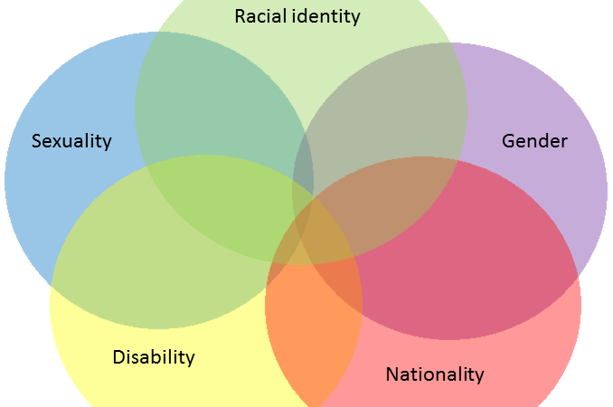

DTC 475: Digital Diversity



Table of Contents

Teaching Philosophy

2

Required Supplies

2

Course Description

3

Schedule / Units

4

Projects / Blogs

10

Grade Breakdown

14

Course Values

14

Sources

16



What Students Say

“Dr. Whitson didn’t just study the topic and whatnot, but it’s part of his life. He’s really interested in computers and their impact on our lives, which was cool.”

“Professor Whitson is eager to hear what the students have to say and to show us why we should care.”

“I loved going and looking at all the old technology. Overall such a good class!”

“I found Dr. Whitson’s class personally challenging, but ultimately fulfilling.”

“Prof Whitson has a very natural talent for teaching, cares about our success, and knows how to keep a class engaged.”



Smartphone



Course Resources

Dr. Whitson

Fellow Students

youcanbookme

Computer and Blackboard

Teaching Philosophy

Asao Inoue argues that “[w]hen you are born into a society that has such histories of racism [as America does], no matter what you think, what you do personally, you will participate in racist structures if you are part of larger institutions like education.” In this class, I see your thoughtfulness, your mindfulness, your engagement and your willingness to rethink your perspective as more important than the course’s outcomes or goals. We all have blind spots, including me. We can all learn from questioning our assumptions.   
  
Instead of trying to be the smartest or funniest person (or conversely instead of being silent, angry, or reactive), what if we practiced kindness, openness, and compassion? As bell hooks says, while students shouldn’t see my classes as therapy sessions “it is appropriate for them to hope that the knowledge received in these settings will enrich and enhance them.” No one who takes this course’s content seriously, who participates regularly, and who turns in assignments in on time should feel anxious about the grade they will receive at the end of the course.

Catalog Description  
475 **[DIVR] Digital Diversity** 3 Course Prerequisite: Junior standing. Cultural impact of digital media in cultural contexts; issues of race, class, gender, sexuality online. (Crosslisted course offered as AMER ST 475, DTC 475, ENGLISH 475).

Course Description

DTC 475 is a continuation of the issues explored in DTC 206, DIGITAL INCLUSION. This course takes as its starting hypothesis the idea that various intersections of oppression exist in the manufacture, programming, design, and disposal of digital technologies. While this course will also explore how, for instance, technology has enabled new methods for visualizing the Other and new forms of accessibility for the differently-abled, it will also argue that these successes are only half of the story. The course proceeds via a series of case studies, emphasizing themes of intersectionality, mindfulness, and access that inform the issues and oppressions we explore.





Demonstrate competency for designing and distributing digital works in various mediums.   
(DTC 1)

Effectively communicate through writing and speech why and how digital media texts make meaning (DTC 6).

Utilize an interdisciplinary perspective in order to understand the global changes brought about by digital media (DTC 5).

Demonstrate an understanding of how digital media and information circulate in multiple cultural contexs (DTC 3).

**Themes:**Themes are recurring ideas in the course that we will use as lenses and tools when explore the material we cover in class. While we will introduce defining themes at the beginning of the class, their lessons will also remain with us throughout the semester. Themes are the settings where our case studies will take place.

|  |  |  |
| --- | --- | --- |
| Theme | Definition | Application to this course. |
| Intersectionality | In *Black Feminist Thought* (1990), Patricia Hill Collins suggests that intersectionality “refers to particular forms of intersecting oppressions, for example, intersections of race and gender, or of sexuality and nation. Intersectional paradigms remind us that oppression cannot be reduced to one fundamental type, and that oppressions work together in producing injustice” (18). | For example, as Lisa Nakamura has pointed out (2014), early semiconductor circuitry was assembled by Navajo women — whose marginalized status meant that they were not protected by U.S. minimum wage laws. But intersectional analyses also include how queer women of color are treated in online gaming communities and the design of adaptive technologies for differently-abled persons that also account for cultural difference. |
| Mindfulness | Mindfulness is the metacognitive awareness of mental and cultural habits and the building of a resilience that is independent of one’s situation.  For angel Kyodo williams, white supremacy is a prison of the mind for white persons who remain blind to the mechanisms of slavery. But mindfulness can act as one tool to “see the patterns of our participation in […] the mind of Whiteness.” | Mindfulness teaches us to empty our thoughts, focus on the present moment, and respond to difficult moments instead of just reacting to them.   “If your mind is empty,” Zen master Suzuki Roshi says, “it is always ready for anything; it is open to everything. In beginner’s mind, there are many possibilities, but in the expert’s there are few.” |
| Access | According to Adam Banks’s *Race, Rhetoric, and Technology*, access means not only *material access*, or being “near places that allow her or him to use computers;” but also *functional access*, “the knowledge and skills necessary to use these tools effectively;” *experiential access*, being “connected enough with those technologies that they actually use them;” and *critical access*, understanding “the benefits and problems of those technologies well enough to be able to critique them when necessary.” | As Banks recounts, “[n]ot only are Black people forced to catch up to technological tools and systems and educational systems to which they have been denied access, but they are required to do so in a nation (or system) in which the struggle they endure to gain any such access to any new technologies, any acquisition of new literacies, is rewarded by a change in the dominant technological systems and the literacies used to facilitate access to them, and thus the same struggle over and over again.” |

# Schedule

*Assignments Are Due On Date Listed. Schedule May Change with Notice from Me*

|  |  |  |  |  |
| --- | --- | --- | --- | --- |
| Class | Hypothesis | In-Class Learning Experiences | Theme Activities | Assignments Due |
| M: 8/20 |  | Introduce Ourselves  Course Overview  Group Read: Alex Myles, [8 Powerful Questions We Should Ask Ourselves Immediately.](https://www.elephantjournal.com/2014/12/8-powerful-questions-we-should-ask-ourselves-immediately/) |  |  |

# Case Study 1: Introductions

This case study introduces the central ideas of the course.

|  |  |  |  |  |
| --- | --- | --- | --- | --- |
| W: 8/22 | Theme 1: Oppression occurs at the intersections of race, gender, class, ability, etc. | Quote: Patricia Hill Collins: “Regardless of social class and other differences among U.S. black women, all were in some way affected by intersecting oppressions of race, gender, and class.”   Watch: (20 Minutes) Kimberle Crenshaw, [“The Urgency of Intersectionality”](https://www.ted.com/talks/kimberle_crenshaw_the_urgency_of_intersectionality)  Think, Pair, Share: Name two benefits Crenshaw sees coming from an intersectional approach to law. |  |  |
| F: 8/24 | Theme 2: Meditation can enable difficult conversations. | **Watch:** (8 Minutes) – angel Kyodo williams, [“What Radical Dharma Means to Me.”](https://www.youtube.com/watch?v=CNgJu1kTNk8)    **Think, Pair, Share:** Check in with how you feel before and after meditation. Do you feel more self-conscious? More open?   **Group Read:** bell hooks, “Engaged Pedagogy” (handout). | **Mindfulness,** (5 Minutes): Headspace Basics 1 |  |
| M: 8/27 | Theme 3: Access means more than being able to locate technology. | Examine: Adam Banks’s Taxonomy of Access (Handout)  Activity: Pick one category in Banks’s taxonomy and discuss how it is impacted by race, gender, and class. |  |  |
| W: 8/29 | Whiteness is a form of social control constructed to ensure economic inequality. | **Listen:** [Seeing White, “How Race Was Made.](http://www.sceneonradio.org/episode-32-how-race-was-made-seeing-white-part-2/)” | **Mindfulness:** [Focusing on What Matters](https://www.youtube.com/watch?v=o7AQ_JbWNJE), angel Kyodo williams |  |
| F: 8/31 | Algorithms are used to automate oppression. | **Quote:** Cathy O’Neil, “Many of these models encoded human prejudice, misunderstanding, and bias into the software systems that increasingly managed our lives.”    **Watch:** Cathy O’Neil, [“Weapons of Math Destruction”](https://www.youtube.com/watch?v=gdCJYsKlX_Y) | **Access:** Pick out one of the three algorithms O’Neil discusses in her talk and give us 1) more information about how it works; 2) the history of its use and; 3) what would need to change in order for people to be able to understand and/or be critical of the model used in the algorithm. |  |
| M: 9/3 | NO CLASS, Labor Day |  |  |  |

# Case Study 2: Seeing Inequity This case study investigates how technology can enable seeing differently.

|  |  |  |  |  |
| --- | --- | --- | --- | --- |
| W: 9/5 | Seeing requires jolting oneself out of complacency. | Watch: Black Palestinian Alliance, [“When I See Them I See Us”](https://www.youtube.com/watch?v=xsdpg-9cmSw)  Think, Pair, Share: How does our sense of identity change with technology? | Intersectionality: What techniques were used in this video to create a sense of solidarity between the protestors of Ferguson and the Palestinians? |  |
| F: 9/7 | Sometimes seeing difference is more important than seeing similarity. | **Quote:** Nicholas Mirzeoff, “Seeing [is] […] that point of intersection between what we know, what we perceive, and what we feel – using all of our senses.”   **Group Read:** Nicholas Mirzeoff, [“Visual Activism”](https://s18798.pcdn.co/howtoseetheworld/wp-content/uploads/sites/1852/2015/05/visual-activism.pdf) | **Access:** What tools are needed today for visual activism? How does visual activism compare to online protest and marching in the streets? | First Post due by midnight. |
| M: 9/10 | Seeing is technological. | Watch: John Berger, [“Ways of Seeing, Episode 1: Photography and Art;”](https://www.youtube.com/watch?v=0pDE4VX_9Kk) (1972)  Think, Pair, Share: How does technology change what we can see? Pick two examples from the film and discuss how they shifted the eye. | Mindfulness: Jeff Warren, [Powers of Ten](http://www.10percenthappier.com/elections/) (also [Too Close](http://jeffwarren.org/archive/too-close/)) |  |
| W: 9/12 | When we can see other people, we feel solidarity with them. | **Quote:** Jacques Ranciere, Politics “makes visible that which had no reason to be seen, [because] it lodges one world into another.”   Group Read: [*Torn Apart, Separados*, “Our Research”](http://xpmethod.plaintext.in/torn-apart/textures.html)   and  **Group Read:** Sergio Flores, [“‘When ICE Is Everywhere’: Using Library Science to Map the Separation Crisis.”](https://www.wired.com/story/ice-is-everywhere-using-library-science-to-map-child-separation/) |  |  |
| F: 9/14 | Technology can also be used to bring about social change. | **Intersectionality/Group Read:** Read and discuss various reflections on their work from participants in the #Separados project. How has race and gender impacted the experience of immigration recounted by these authors?  [Roopika Risam](http://xpmethod.plaintext.in/torn-apart/reflections/roopika_risam.html), [Moacir P. de Sá Pereira](http://xpmethod.plaintext.in/torn-apart/reflections/moacir_p_de_sa_pereira.html), [Durba Mitra](http://xpmethod.plaintext.in/torn-apart/reflections/durba_mitra.html), [Maira Álvarez](http://xpmethod.plaintext.in/torn-apart/reflections/maira_alvarez.html), [Manan Ahmed](http://xpmethod.plaintext.in/torn-apart/reflections/manan_ahmed.html), [Nicole M. Guidotti-Hernández](http://xpmethod.plaintext.in/torn-apart/reflections/guidotti_hernandez.html) |  |  |
| M: 9/17 |  | In-class work on #Separados. |  |  |
| W: 9/19 | NO CLASS | Work on First Project |  | 1st Short Assignment  Due by Midnight. |

# Case Study 3: Cochlear Implants and Deaf Culture This case study investigates deaf culture and their response to the rise of cochlear implants as an accessible technology.

|  |  |  |  |  |
| --- | --- | --- | --- | --- |
| M: 9/24 | Sound is everywhere, even in silence. | Watch: NPR, [“A Death Metal Band Covers 4’33’”](http://www.npr.org/event/music/476012094/the-sound-of-crushing-silence-a-death-metal-band-covers-john-cages-433) Write Down Everything You Hear While Listening.  Watch: John Cage, [“On Silence”](https://www.youtube.com/watch?v=pcHnL7aS64Y)  Think, Pair, Share: Discuss with a partner what you wrote. | Mindfulness: Matthew Hepburn, 10% Happier, “The World of Sound” |  |
| W: 9/26 | Bodies are the locus of our experiences. | **Quote:** Maurice Merleau-Ponty, My body is “the darkness needed in the theatre to show up the performance, […] the zone of not being in front of which precise beings, figures and points can come to light.”  **Group Read:** H. Dirksen Bauman, [“Listening to Phonocentrism with Deaf Eyes: Derrida’s Mute Philosophy of (Sign) Language.”](https://commons.pacificu.edu/cgi/viewcontent.cgi?article=1288&context=eip) | **Access:** How do we understand access in terms of our body? Consider the role of sound in constructing your sense of space and the body. |  |
| F: 9/28 | NO CLASS, Professor at Meditation Retreat |  |  |  |
| M: 10/1 | Cochlear Implants deliver radically different forms of sound than organic ears. | **Listen:** [Cochlear Implant Simulation](https://www.youtube.com/watch?v=SpKKYBkJ9Hw) **Watch:** Michael Chorost, [“A Resonance of the Senses: The Surprising Connections Between Deafness, Implanted Computers, and Touch.”](https://techtv.mit.edu/videos/3547-speakers-and-signers-michael-chorost-a-resonance-of-the-senses-the-surprising-connections-between-dea) | **Recommended:** Liz Bowen, [“The Cochlear Implant at the End of the World”](https://thenewinquiry.com/the-cochlear-implant-at-the-end-of-the-world/) |  |
| W: 10/3 | The history of deaf culture gives a different perspective on cochlear implants. | **Watch:** *Through Deaf Eyes* (2007) | **Intersectionality:** How does this film address race and gender in deaf culture? |  |
| F: 10/5 |  | **Watch:** *Through Deaf Eyes* (2007) |  | 2nd Short Assignment  Due by Midnight. |

# Case Study 4: Neurodiversity and Communication This case study explores the history of adaptive technologies and universal design used for differently-abled persons.

|  |  |  |  |  |
| --- | --- | --- | --- | --- |
| M: 10/8 | Apple is a leader in digital accessibility, and has been for many years. | Group Read: Tim Carmody, [“This Stuff Doesn’t Change the World: Disability and Steve Jobs’s Legacy.”](https://www.wired.com/2011/10/steve-jobs-disability/) | Accessibility: If you have an Apple computer, take a look at the apps described in Carmody’s article. Consider how they change the lives of people who are differently-abled. |  |
| W: 10/10 | Facilitated communication is a controversial method for communicating with neurodiverse individuals. | **Watch:** [Frontline,Prisoners of Silence (1993)](https://vimeo.com/22621954) |  |  |
| F: 10/12-16 | NO CLASS, Professor at Conference |  |  |  |
| M: 10/22 | Neuroqueer is both a noun and a verb. | **Quote:** Melanie Yergeau, “The logics of ableism are intertwined with the logics of racism, classism, and heterosexism.”  **Group Read:** Nick Walker, [NeuroQueer: An Introduction.](http://neuroqueer.blogspot.com/2015/05/neuroqueer-introduction-by-nick-walker.html); and EJ Grace, NeuroQueer: What and Why [1](http://neuroqueer.blogspot.com/2013/07/what-i-mean-why-part-1-queer.html) and [2](http://neuroqueer.blogspot.com/2013/07/what-i-mean-why-part-1-queer.html) | **Mindfulness:** Sharon Salzberg,10% Happier, “The Myth of Separation” |  |
| W: 10/24 | Often assumptions about race and sexuality are bound up in our judgments about cognitive deficits. | **Watch:** Anna Stubblefield, [“The Entanglement of Race and Cognitive Disability”](https://www.youtube.com/watch?v=KokY8hSTYjQ)  **Group Read:** Daniel Engber, [“The Strange Case of Anna Stubblefield.”](https://www.nytimes.com/2015/10/25/magazine/the-strange-case-of-anna-stubblefield.html) | **Intersectionality:** How does Stubblefield articulate the way race is used to limit differently-abled persons? |  |
| F: 10/26 | Protectionism can be another version of ableism. | **Group Read:** David Perry, [“Sexual Ableism”](https://lareviewofbooks.org/article/sexual-ableism/#!) |  |  |
| M: 10/29 | NO CLASS |  |  | Second Project Due at Midnight |

# Case Study 5: Labor in the Global South This case study explores the history of adaptive technologies and universal design used for differently-abled persons.

|  |  |  |  |  |
| --- | --- | --- | --- | --- |
| W: 10/31 | Since mid-century, most commodities have been made in factories across the world by people who don’t know each other. | Watch: [Planet Money Makes a T-Shirt](http://apps.npr.org/tshirt/#/title)  Think, Pair, Share: Rewatch one part of the Planet Money piece, and research the specifics of that element of the global supply chain. | Intersectionality: Find one way intersectionality impacts workplace oppression. |  |
| F: 11/2 | Computers are made from many components whose origin, function, and purpose are obscured from us. | **Watch:** iFixit, [The iPhone 7 Plus Teardown](https://www.youtube.com/watch?v=0s_zg4_DZp8)  **Research:** Identify one of the parts discussed in the teardown and research where it is made, what it is made of, and what it does. | **Access:** Note what technologies, knowledges, and privileges you needed in order to perform your research. |  |
| M: 11/5 | Call centers engage in hacking and phishing attempts on unsuspecting victims. | **Listen:** Reply All, [“Long Distance”](https://www.gimletmedia.com/reply-all/long-distance#episode-player) |  |  |
| W: 11/7 |  | **Listen:** Reply All, [“Long Distance Part II”](https://www.gimletmedia.com/reply-all/103-long-distance-part-ii#episode-player)  **Check Out:** As you listen, check out Alex Goldman’s [Ask Me Anything](https://www.reddit.com/r/IAmA/comments/6rdxyy/we_are_the_hosts_and_staff_of_the_reply_all/) about the episode on Reddit. |  |  |
| F: 11/9 | The global south continues to be a source of cheap and sometimes illegal labor. | **Watch**: *Maquilapolis: City of Factories (2006)* | **Mindfulness:** Shenzen Young, [“Do Nothing”](https://www.youtube.com/watch?v=cZ6cdIaUZCA) |  |
| M: 11/12 | NO CLASS – Veteran’s Day |  |  |  |
| W: 11/14 |  | **Watch**: *Maquilapolis: City of Factories (2006)* |  | Final Short Assignment Due  at Midnight |
| 11/16-23 | NO CLASS – Thanksgiving Break |  |  |  |

# Conclusions: Waste and the Anthropocene

|  |  |  |  |  |
| --- | --- | --- | --- | --- |
| M: 11/26 | Often, our devices end up in large dumps in the Global South. | Watch: [*E-Wasteland*](https://www.youtube.com/watch?v=yUCoToorc9M)  As You Watch: Check out the Hazardous substances table on the [Electronic Waste Wikipedia](https://en.wikipedia.org/wiki/Electronic_waste#See_also) page. | Access: Consider how Banks’s categories operate in the Ghana E-Waste Trade. |  |
| W: 11/28 |  | **Watch:** *How to Let Go of The World and Love All the Things Climate Can’t Change.* | **Mindfulness:** 10% Happier,Jeff Warren, The Arc of Practice / Centeredness |  |
| F: 11/30 |  | **Watch:** *How to Let Go of the World and Love All the Things Climate Can’t Change.* |  |  |
| M: 12/3 |  | **Finish:** *How to Let Go of the World and Love All the Things Climate Can’t Change.* | **Intersectionality:** As you watch the rest of the film, consider how the director represents the intersectional consequences of climate change. |  |
| W: 12/5 |  | **Mindfulness:** “Just Like Me” from *Contemplative Practices in Higher Education*.   **Final Reflection:** How can we support one another as we finish this course and this semester? |  |  |
| F: 12/7 | NO CLASS |  |  | Final Project Due at Midnight |

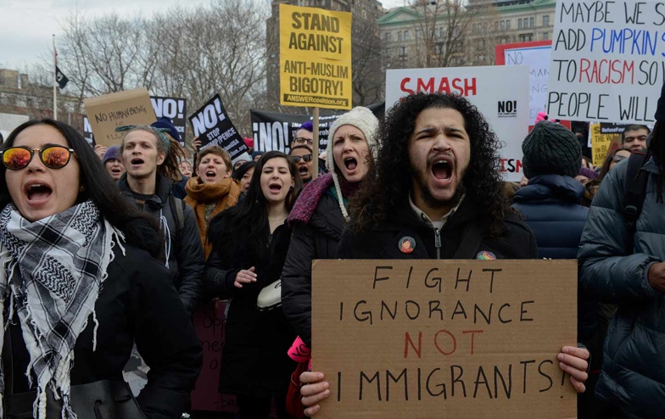

People Protest Against Immigration Policy

and Raids from ICE.   
Photo credit: Reuters/Stephanie Keith)



Project 1: Intersectionality

DUE: 9/20; from Roopika Risam

**Action**: Work collaboratively on the #Separados project.

**Research:** Explore one self-proclaimed sanctuary city and cross-reference with a list of known ICE facilities. Are there sanctuary cities that are taking money from ICE and also allowing ICE to have detention facilities in its boarders?   
  
**Create**: Record your data in Excel or Google Spreadsheets. Create a map of your data to be visualized on __________.   
  
  
**Reflect:** 600 words. What does it mean to use technology and public data to visualize detention centers? Is there a contradiction between using ICE money and housing separated children and calling yourself a sanctuary city? Connect your thoughts to any one of the articles on the *Separados* project or the individual reflections.

.

Rubric (75 first row, 50 for last two rows; 200 total)

|  |  |  |
| --- | --- | --- |
| Needs Work | Criteria | Exceeds Standards |
|  | **Data:** Complete and accurate spreadsheet of 1) sanctuary cities; 2) money taken from ICE; 3) detention facility locations. |  |
|  | **Map:** Visualizations of cross-referenced data accurately reflects the data you gathered. |  |
|  | **Reflection:** 300 words discussing the social and cultural implications of your work and relating your thoughts to readings in class. |  |

|  |  |  |
| --- | --- | --- |
| Needs Work | Criteria | Exceeds Standards |
|  | **Checklist:** New criteria for accessibility are created by the group based upon their observations of accomodation needs. |  |
|  | **Group Work:** Each member of the group does an appropriate amount of the work. If one group member does  less work than the others, this is where they will lose points.  t |  |
|  | **Write-Up:** 750-word discussion of accessibility based upon agreed-upon criteria. |  |
|  | **Individual Reflection:** 300-words on process, connection to readings. |  |



Project 2: Disability

***DUE: 10/11*;** Student Project [Examples.](https://drive.google.com/drive/folders/0B-h_I_KLxUTLaGpSX1NFMllmd0E)

**Objectives:**. Audit a space/technology on campus for accessibility in groups of 3-4.

**Pick:** A space that you can reasonably observe, analyze, and take notes on in the space of a couple of hours. “One floor of the Spark” or “the Bookie” would be a good size for the audit.

**Use:** The checklist combining criteria from the Americans with Disabilities Act (ADA), those developed by disability studies scholars, and at least 4 criteria you add to the checklist.

**Write:** Consider the following questions:

* What does access mean in your experience?
* What features of particular spaces make those spaces accessible for you? For others you know?
* What are some barriers to access that you can think of?

**Write-Up and Reflect:** After conducting the audit, consider the following:

* At least 750 words and individual 300 word- reflection.
* How large is this space? How many people use it? What light is used?
* What are highlights from your checklist? What barriers? Include photos.
* What recommendations would you make to people who maintain or use this space?

Parody of Margritte,

Icon for the Centre for Excellence in Universal Design

Rubric (75 first row, 50 for last two rows; 200 total).   
Group grades unless members do not balance work.

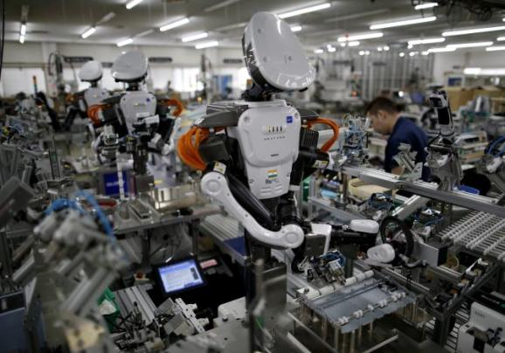



Project 3: Labor

*DUE: 12/10/2016*; By Miriam Posner

**Objectives**: Create a Scalar essay that explains how a particular electronic device was created.

**Action:** Explore these four dimensions:

* *Ownership*: What company produces this device? What is the corporation’s background and what else does it produce?
* *Components:* Determine the metals, chemicals, and other components that make up the device.
* *Supply Chain*: Where do the parts come from? Where were the parts mined/synthesized/extracted? Who did this work?
* *Waste:* How is this device disposed of? Where does it go? Is it repurposed? Do any of the components create pollutants?

Create: One multimedia essay using Scalar. Check out Jason Mittell’s [Complex Television](http://scalar.usc.edu/works/complex-television/index) for an example. At a minimum, it should include an essay of 1500 words and 10 images, but you can also incorporate video, sounds, photographs, etc.

**Reflect:**300-words in an “about” page where you reflect on your design choices and connect them to at least one of the readings.

Humanoid Robots work with Human   
Employees in a Factory in Kazo, Japan  
Image Credit: Reuters, Issei Kato

Rubric (50pts each row; 200 pts total). Individual Grades.

|  |  |  |
| --- | --- | --- |
| Needs Work | Criteria | Exceeds Standards |
|  | **Narrative:** Argument is thought-provoking and filled with real-world examples and details. |  |
|  | **Media:** Media is carefully selected and supports the argument of the narrative logically and aesthetically. |  |
|  | **Citations:** At least three sources from the unit’s reading and incorporated them logically into the argument. |  |
|  | **Reflection:** You will need to create an “about” page that includes not only a discussion of the design choices in your Scalar project, but also relates them to the cited sources. |  |

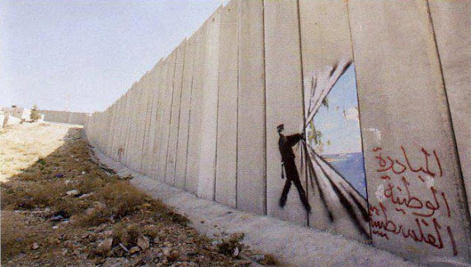Short Assignments

1: Visual Activism

**Action**: Engage in a small act of visual activism with your group.   
  
**Identify:** Identify one population on campus who isn’t being represented, and formulate a plan for visualizing them. Consider whether you want to create a collection of photographs or a video. At least 10 photographs, with descriptions or a 10-minute film.

**Reflect:** Write 600 words as a group about 1) your project; 2) the group you wanted to make visible; 3) and relate it to Mirzeoff, Berger, or the other photographic projects we’ve explored in this case study.

Disability: J Rotenberg Archive

**Action:** Pick one archival document from the [Judge Rotenberg Center (JRC)](https://autistichoya.net/judge-rotenberg-center/) and describe the event depicted in the document, what the event says about the treatment of people with disabilities in America, and how this treatment differs in terms of race, gender, and class.

**Present:** Your findings in class.



Disability

**Action**: Read Tara Wood and Shannon Madden’s [“Suggested Practices for Syllabus Accessibility Statements.”](http://kairos.technorhetoric.net/praxis/tiki-index.php?page=Suggested_Practices_for_Syllabus_Accessibility_Statements) Explore the accessibility statements in three separate syllabi you’ve received this semester. If you haven’t received this many, borrow a few from a classmate.   
  
**Reflection:** How accessible are the courses you take on WSU campus? How do these accessibility statements differ, and if they do not, why do you think they are the same?   
  
  
**Connect** your reflections to Bauman, Chorost, or *Through Deaf Eyes*.



Labor / Mindfulness

**Action**: Consider one of the posts on the [Headspace Blog about Work](https://www.headspace.com/blog/category/work/). For a week, try out their recommendations.   
  
**Reflection:** How was your experience? How do you understand the connection between mindfulness and work? Did it allow you to work with less stress?   
  
  
**Connect** your reflections with one of the meditations we experienced this semester.





# Grade Breakdown (200 pts each 1000 pts total)

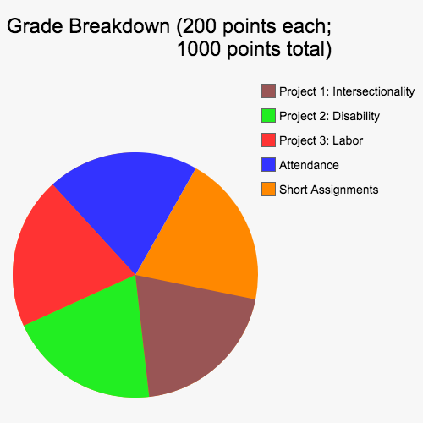

Course Values

Inclusion: Your success in this class is important to me. We will all need accommodations because we all learn differently. If there are aspects of this course that prevent you from learning our exclude you, please let me know as soon as possible. The sooner I know about these, the earlier we can discuss possible adjustments or alternative arrangements that might help you. If you have a documentable disability, please visit the Access Center (Washington Building 217; 509.335.3417) to schedule an appointment with an advisor.

Time Bank: I have built-in grace periods for the due dates of major assignments. You may choose to take:

* 1 two-day grace period for one major project.
* 2 one-day grace periods for two major projects.

Contract Weighing: I realize you may be more interested in some aspects of this course than others. You may reassign a total of 15% of the final grade in any allotment you wish, as long as your grade adds up to 100%. Some examples:

* Remove 10% from the Video Games project and 5% from Participation, then add 10% to Blogs / Exercises and 5% to the Social Media Project.
* Remove 15% from Blogs / Exercises and add 15% to the Data Tracking Project.
* Remove 5% from all 3 major projects, add 10% to Participation and 5% to Blogs.

Attendance: I hope you participate actively in the course, because this is the best way for me to engage you in learning. Taking daily attendance is also a good way for me to learn your names and to know who you are. Of course, we all participate differently, and I’ve built-in mechanisms to help ensure that you can engage the content in a variety of ways. If you have any difficulties with regular participation, please talk to me.

Email: I would rather talk to you in person than via email, since email depersonalizes the exchange and makes it easier for me to misinterpret what you mean. If emailing me is necessary, please allow me at least 24 hours to respond to your email inquiries. I try to respond in a timely manner, but I do not always check my email when not in town or on the weekends.

Reading and Homework: I encourage you to read all of the work for this course, since it enables us to complete discussions, ideas, and projects. I also know that college can be busy, as it was for me. I consider this class a *learning community*, and such a community works better if everyone has read the proper materials. If you are consistently finding it difficult to complete your readings, please talk to me and we’ll try to figure out a workable solution.

Academic Honesty: Everyone in this class, including me, must abide by the standards of academic honesty set up by Washington State University. See that statement here: [http://wsulibs.wsu.edu/library-instruction/plagiarism.](http://wsulibs.wsu.edu/library-instruction/plagiarism) I work hard to model appropriate academic citation. Please see me if you are unclear about any of these requirements.

Safety: Washington State University is committed to enhancing the safety of the students, faculty, staff, and visitors. It is highly recommended that you review the Campus Safety Plan (<http://safetyplan.wsu.edu/)>and visit the Office of Emergency Management website (<http://oem.wsu.edu/)>for a comprehensive listing of university policies, procedures, statistics, and information related to campus safety, emergency management, and the health and welfare of the campus community.

# Sources

## Assignments:

Miriam Posner and Franky Abbott. [“Final Project.”](http://digitalmateriallabor.org/final-project/) *DH 150: Digital Labor, Urban Space, and Materiality*. Winter 2014: UCLA.

Margaret Price. [“Accessibility Audit.”](https://docs.google.com/document/d/1f2GBFqp29ThIfro1oM9L7u3ZlLJlxJ-PEK2GX428mww/edit) *ENGL 389: Composing Disability, Health and Wellness*. Spring 2014: The Ohio State University.

Roopika Risam. “#Separados.”

## Readings:

Jennifer Barclay. *WST 120: Race, Gender and Reproduction in Global Health Politics.* Fall 2017: Washington State University.

Mirabai Bush and Daniel Barbezat. *Contemplative Practices in Higher Education*. Wiley-Blackwood, 2014.

Nicholas Mirzeoff. [*The Appearance of Black Lives Matter*.](https://namepublications.org/item/2017/the-appearance-of-black-lives-matter/)[Name] Publications, 2017.

Anna Plemons. *DTC 206: Digital Inclusion.* Spring 2018: Washington State University.

George Williams. [“Access.”](https://digitalpedagogy.mla.hcommons.org/keywords/access/) *Digital Pedagogy in the Humanities: Concepts, Models, and Experiments*. Ed. Rebecca Frost Davis, Matthew K. Gold, Katherine Harris, and Jentery Sayers. MLA Commons.

Melanie Yergeau. [“Disability.”](https://digitalpedagogy.mla.hcommons.org/keywords/disability/) *Digital Pedagogy in the Humanities: Concepts, Models, and Experiments*. Ed. Rebecca Frost Davis, Matthew K. Gold, Katherine Harris, and Jentery Sayers. MLA Commons.

## Policies and Design:

John Aycock and Jim Uhl. “Choice in the Classroom.” *ACM SIGCSE Bulletin*. 37.4 (2005): 84- 88.

Ashley Boyd. *Young Adult Literature*. Fall 2015: Washington State U.

Anne-Marie Womack, Annelise Blanchard, Cassie Wang, Mary Catherine Jessee. *Accessible Syllabus*. Web. 3 August 2016.

Anne-Marie Womack. *First-Year Writing: Rhetoric and Research in the Digital Era*. Spring 2014: Tulane U.